CRM Dashboard-Opportunities: From the Dashboard, click on Opportunities on the dark blue toolbar.

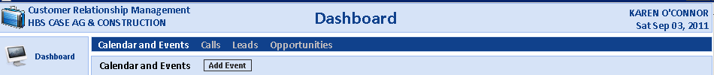

This brings up a full display of all the Opportunities (for an individual salesman or all salesmen). They sort so the most current ones are at the top.

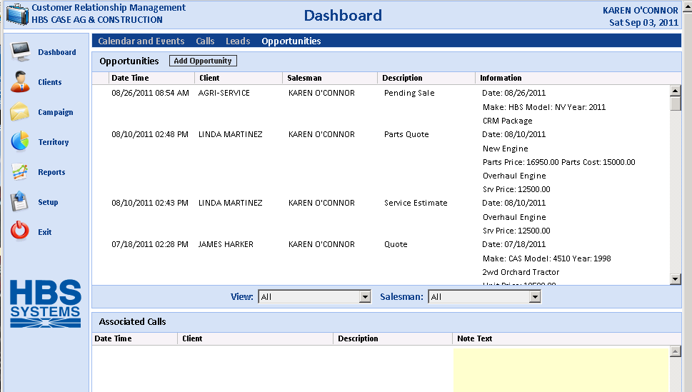

You can review opportunity information by clicking on it.

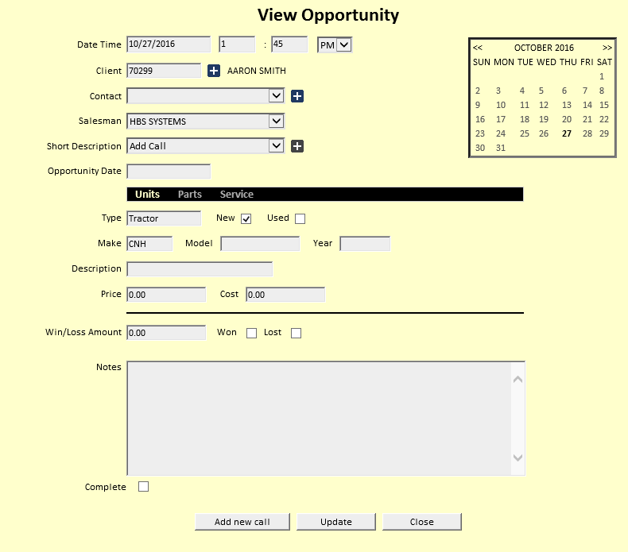

Add Opportunity: To add an opportunity, click the Add Opportunity button.

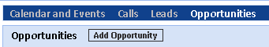

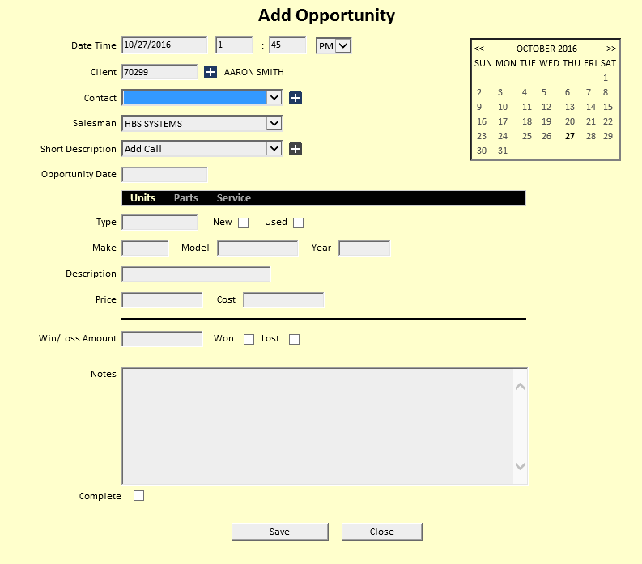

Date and Time: The Date and Time pre-fill with today's date and the current time. Change as needed.

Client: Type in the A/R Customer Number, or look up the customer by typing in a few letters of their last name or business name.

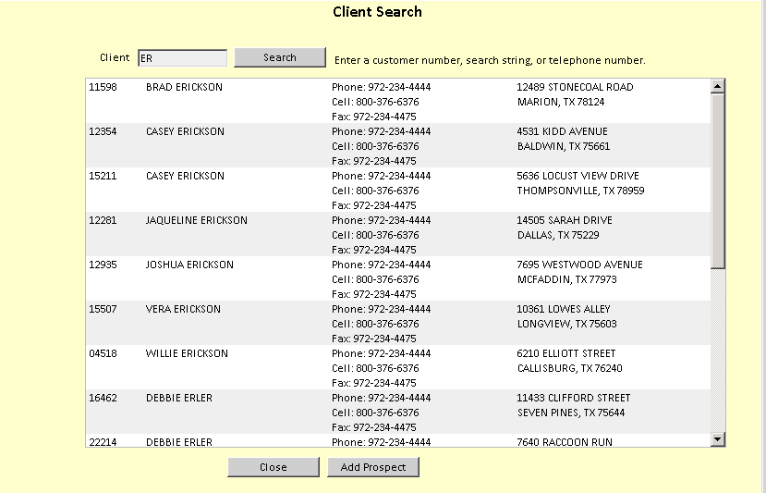

Contact: Choose a contact name from the drop-down menu. If you want to add a new contact:

- Click on the plus (+) sign.
- Fill in the fields that appear.
- Click Save.

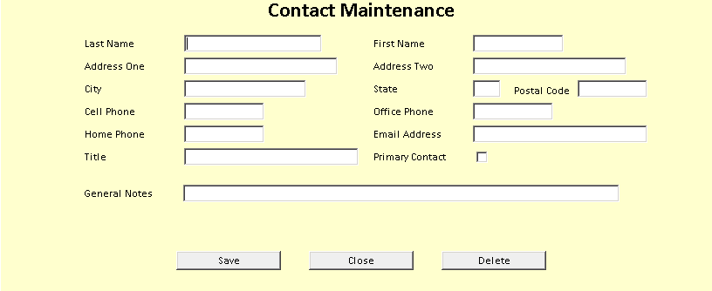

Salesman: The Salesman will default to your login. Sales Managers may choose individual salesman IDs.

Short Description: Choose an option from the drop-down menu.

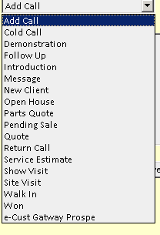

Opportunity Date: Fill in date of the opportunity.

Unit Opportunity: With the Unit Opportunity, you have the option of entering the following:

- Type
- New/Used status
- Make
- Model
- Year
- Description
- Selling Price
- Cost
- Win/Loss Amount
- Win/Loss Status boxes
- Any additional notes

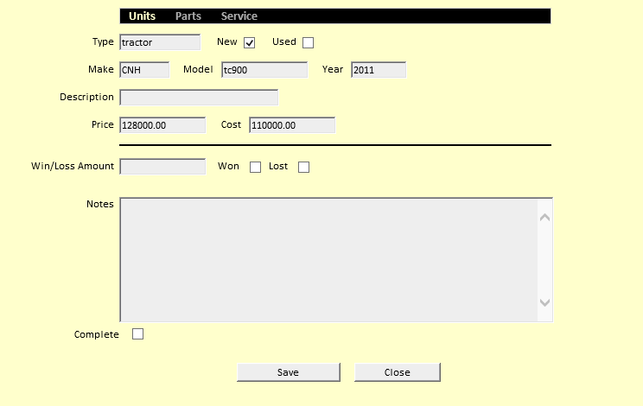

Parts Opportunity: With the Parts Opportunity, you have the option of entering the following:

- Description
- Selling Price
- Cost
- Win/Loss Amount
- Win/Loss Status boxes
- Any additional notes

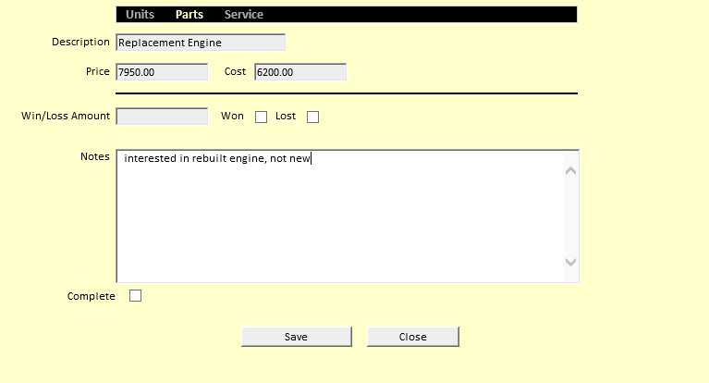

Service Opportunity: With the Service Opportunity, you have the option of entering the following:

- Description
- Selling Price
- Cost
- Win/Loss Amount
- Win/Loss Status boxes
- Any additional notes

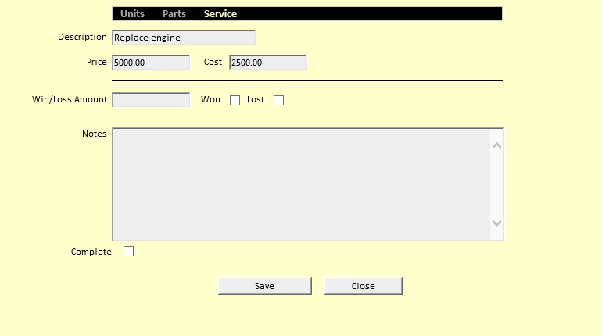

Complete: Check this box to change the opportunity status from Active to Closed.

Press “Save” to record the Opportunity information.

Add from the Client screen: You may also add opportunities from the Client screen.

Choose a client.

Click on Opportunities in the lower portion of the screen.

Click on Add Opportunity.

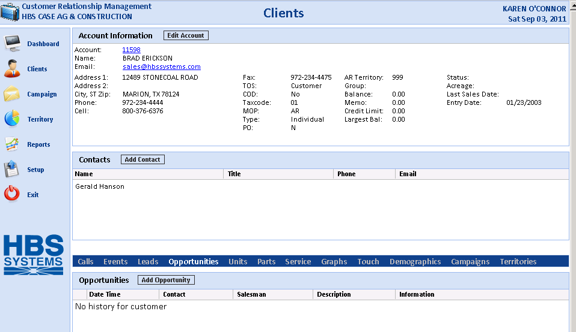

Converting a Lead to an Opportunity: In the Leads section of your Dashboard or inside a Client record in the Leads screen, select an existing lead and then check the box that says Convert to Opportunity.

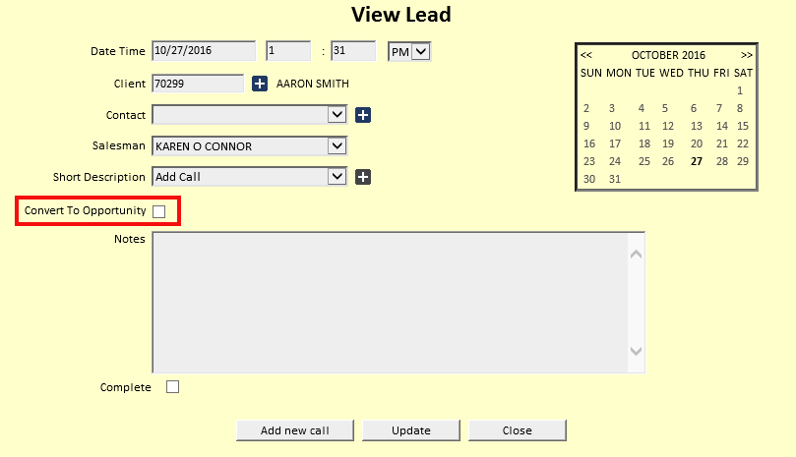

Once you check the Opportunity box, the bottom of the screen shows all the opportunity fields.

